**Setup Menu**

# Hew Lines VA7HU and Aki Yoshida JA1NLX

## 1.0 General



## 8.0 FREQUENCY MENU ITEM

The **FREQUENCY** menu item allows the user to select the frequency format to be used by Logger32 from a drop-down menu list.

**Show frequency Display & Log frequency**  
Always check this option if you want to see frequency in Logbook Entry Window and log frequency.

**Enable frequency change UDP Broadcast**  
Check this option if other device need frequency data. Frequency data is distributed at UDP Port 12061. The data format is like this.

<?xml version="1.0"?>  
<RadioInfo>  
<Freq>1420123.4</Freq>  
</RadioInfo>

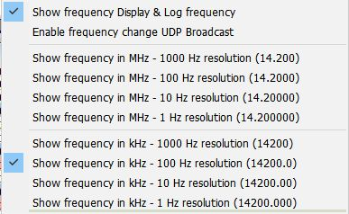

new SM_14

## 9.0 ANTENNA SELECTOR MENU ITEM

The **ANTENNA SELECTOR** menu item displays the Antenna Selector dialog box that enables the user to configure Logger32 to use an electronic antenna switch to automatically select different antennas for different bands. Details can be found in the Setup Antenna Selector topic.